EXPOSURE DIAGRAM
Note that the parameter associated with the arrow between a source state and a sink state represents the daily transition probability to that sink state conditional on occupancy of the source state. Also note that prevalence across all 5 states (including mortality) sum to 1.
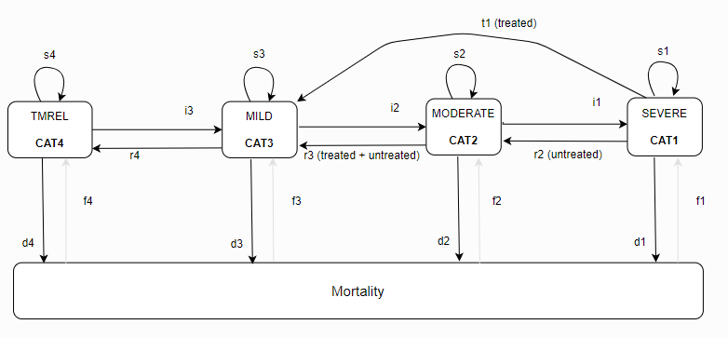

PARAMETER TABLE
Parameter | Description | Status | Value
$$i_{3}$$ | Daily incidence probability from TMREL to mild | Known | Sampled from KI data
$$i_{2}$$ | Daily incidence probability from mild to MAM | Known | Sampled from KI data
$$i_{1}$$ | Daily incidence rate from MAM to SAM | Known | Sampled from KI data
$$i_{c}$$ | Daily incidence rate from uncomplicated to complicated SAM | Known | Derived from sampled value of proportion of uncomplicated SAM cases who are referred to inpatient treatment after enrolling in outpatient treatment (parameter=complicated_sam_deterioration_proportion) and the time to recovery of uncomplicated SAM with outpatient treatment parameter.  Derivation:
$$r_{4}$$ | Daily recovery probability from mild to TMREL | Unknown | Solved below
$$r_{3}$$ | Daily recovery probability from MAM to mild, pooled across treated and untreated | Unknown | Solved below
$$r_{2}$$ | Daily recovery probability from SAM to MAM for those untreated or ineffectively treated | Unknown | Solved below
$$t_{1}$$ | Daily recovery probability to mild of effectively treated SAM | Known | rate_to_prob(r_sam_ux)
$$d_{4}$$ | Daily mortality probability from TMREL | Known | rate_to_prob(mort_cat_4); from GBD (see CGF risk effects model document for more details)
$$d_{3}$$ | Daily mortality probability from mild | Known | rate_to_prob(mort_cat_3); from GBD (see CGF risk effects model document for more details)
$$d_{2}$$ | Daily mortality probability from MAM | Known | rate_to_prob(mort_cat_2); from GBD (see CGF risk effects model document for more details)
$$d_{1}$$ | Daily mortality probability from SAM | Known | rate_to_prob(mort_cat_1); from GBD (see CGF risk effects model document for more details)
$$f_{4}$$ | Probability of “birth” into TMREL from death pool | Known | Prev cat 4; from GBD
$$f_{3}$$ | Probability of “birth” into mild from death pool | Known | Prev cat 3; from GBD
$$f_{2}$$ | Probability of “birth” into MAM from death pool | Known | Prev cat 2; from GBD
$$f_{1}$$ | Probability of “birth” into SAM from death pool | Known | Prev cat 1; from GBD
$$p_{4}$$ | Death pool adjusted TMREL prevalence | Known | Prev cat 4 / (1 + rate_to_prob(acmr))
$$p_{3}$$ | Death pool adjusted mild prevalence | Known | Prev cat 3 / (1 + rate_to_prob(acmr))
$$p_{2}$$ | Death pool adjusted MAM prevalence | Known | Prev cat 2 / (1 + rate_to_prob(acmr))
$$p_{1}$$ | Death pool adjusted SAM prevalence | Known | Prev cat 1 / (1 + rate_to_prob(acmr))
$$p_{0}$$ | Death pool prevalence | Known | rate_to_prob(acmr) / (1 + rate_to_prob(acmr))
$$C_{SAM}$$ | Coverage of SAM | Known | Defined on wasting treatment intervention model document
$$E_{SAM}$$ | Efficacy of SAM | Known | Defined on wasting treatment intervention model document
$$C_{MAM}$$ | Coverage of MAM treatment | Known | Defined on wasting treatment intervention model document
$$E_{MAM}$$ | Efficacy of MAM treatment | Known | Defined on wasting treatment intervention model document
$$r_{SAM,tx}$$ | Annual recovery rate to mild for effectively treated SAM | Known | Defined on wasting treatment intervention model document
$$r_{SAM,ux}$$ | Annual recovery rate of untreated SAM | Unknown | Prob_to_rate(r2)
$$r_{MAM,tx}$$ | Annual recovery rate of treated MAM | Known | Defined on wasting treatment intervention model document
$$r_{MAM,ux}$$ | Annual recovery rate of untreated MAM | Unknown | Solved below

EQUATIONS USED TO SOLVE FOR UNKOWNS:
These equations are true under the assumption of a steady state equilibrium. Under these conditions, the rate of flow out of a given state in the system must equal the rate of flow into that state. Equations 1 through 4 represent these steady state flow equations. Equation 5 is the decomposition of the recovery probability from MAM to mild into the untreated and treated recovery rates (based on what we know about the treated recovery rate).
Eq1 (cat4 steady state) | $$r_{4}*p_{3}+f_{4}*p_{0}-i_{3}*p_{4}-d_{4}*p_{4}=0$$
Eq2 (cat3 steady state) | $$i_{3}*p_{4}+r_{3}*p_{2}+f_{3}*p_{0}+t_{1}*p_{1}*C_{SAM}*E_{SAM}-r_{4}*p_{3}-i_{2}*p_{3}-d_{3}*p_{3}=0$$
Eq3 (cat2 steady state) | $$i_{2}*p_{3}+r_{2}*p_{1}*(1-C_{SAM}*E_{SAM})+f_{2}*p_{0}-r_{3}*p_{2}-i_{1}*p_{2}-d_{2}*p_{2}=0$$
Eq4 (cat1 steady state) | $$i_{1}*p_{2}+f_{1}*p_{0}-r_{2}*p_{1}*(1-C_{SAM}*E_{SAM})-t_{1}*p_{1}*C_{SAM}*E_{SAM}-d_{1}*p_{1}=0$$
Eq5 (mam recovery stratification into treated and untreated) | $$r_{3}={rate to prob(r}_{MAM,tx})*C_{MAM}*E_{MAM}+{rate to prob(r}_{MAM,ux})*\left(1-C_{MAM}*E_{MAM}\right)$$

VALUES FOR UNKNOWNS:
$$r_{4}={(d}_{4}*p_{4}+i_{3}*p_{4}-f_{4}*p_{0}){/p}_{3}$$
$$r_{2}=\frac{i_{1}*p_{2}+f_{1}*p_{0}-t_{1}*p_{1}*C_{SAM}*E_{SAM}-d_{1}*p_{1}}{p_{1}*(1-C_{SAM}*E_{SAM})}$$
$$r_{3}=\frac{d_{3}*p_{3}+i_{2}*p_{3}+r_{4}*p_{3}-t1*p_{1}*C_{SAM}*E_{SAM}-i_{3}*p_{4}}{p_{2}}$$
$$r_{MAM,ux}=prob to rate(\frac{r_{3}-rate to prob (R_{MAM,tx})*C_{MAM}*E_{MAM}}{1-C_{MAM}*E_{MAM}})$$

